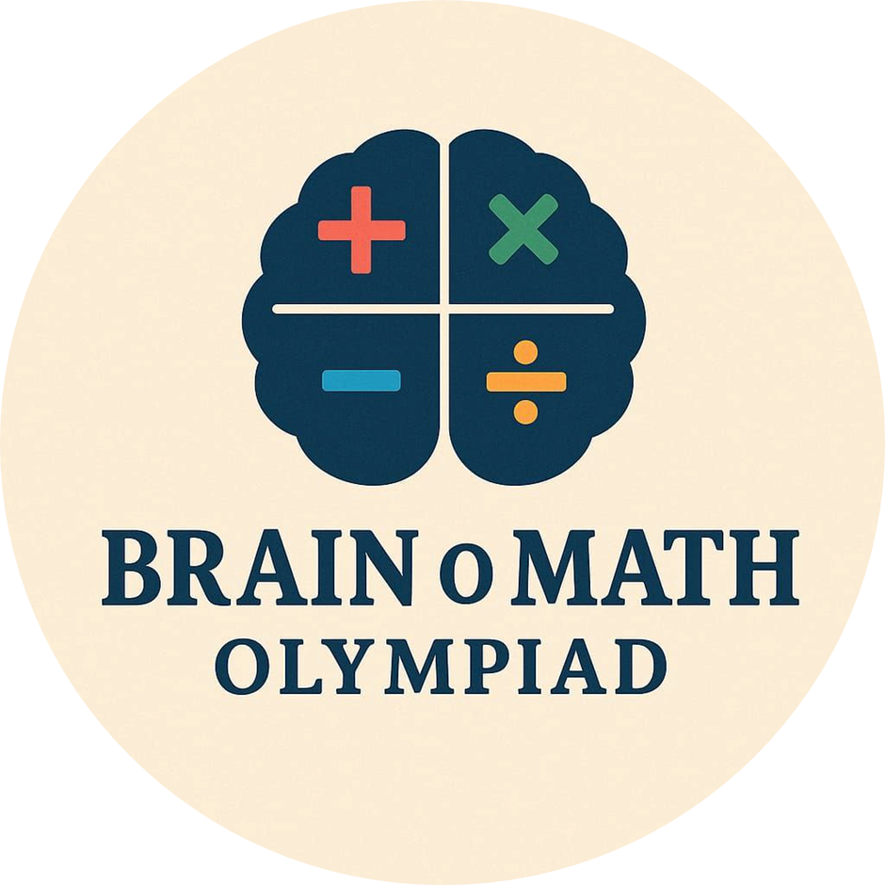
BrainoMath Olympiad 2026

Brain-O-Math Olympiad 2026 – Important
Particulars | Details
Last Date to Apply | 27 July 2026
Admit Card Release | 29 July 2026
English Examination | 7 August 2026 (1:00 PM – 2:00 PM)
Computer Science Examination | 7 August 2026 (2:30 PM – 3:30 PM)
Mathematics Examination | 8 August 2026 (9:30 AM – 10:30 AM)
Science Examination | 8 August 2026 (11:00 AM – 12:00 PM)
Result Declaration | 1 October 2026
Award Ceremony | 6 October 2026
Registration Fee | ₹100 per subject
Award | Silver Medal for the highest scorer in any one subject.

- Total Question Paper Sets

Category | Classes | Subject
Category A | Classes III–IV | Mathematics, Science, English & Computer Science
Category B | Classes V–VI | Mathematics, Science, English & Computer Science
Category C | Classes VII–VIII | Mathematics, Science, English & Computer Science
Category D | Classes IX–X | Mathematics, Science, English & Computer Science
Category E | Classes XI–XII | Mathematics, Science, English & Computer Science
Grand Total | III–XII | 20 Subject Papers

N

- .

Question Paper Blueprints

English Olympiad (Classes III–XII)
Section | Questions | Marks per Question | Total Marks
Word & Structure Knowledge | 30 | 1 | 30
Reading Comprehension | 10 | 1 | 10
Language Expression | 5 | 1 | 5
Achievers Section (HOTS) | 5 | 3 | 15
Grand Total | 50 |  | 60

Computer Science Olympiad (Classes III–XII)
Section | Questions | Marks per Question | Total Marks
Logical Reasoning | 10 | 1 | 10
Computer Science | 30 | 1 | 30
Artificial Intelligence | 5 | 1 | 5
Achievers Section (HOTS) | 5 | 3 | 15
Grand Total | 50 |  | 60

Science Olympiad (Classes III–X)
Section | Questions | Marks per Question | Total Marks
Logical Reasoning | 10 | 1 | 10
Science | 35 | 1 | 35
Achievers Section (HOTS) | 5 | 3 | 15
Grand Total | 50 |  | 60

Science Olympiad (Classes XI–XII)
Section | Questions | Marks per Question | Total Marks
Physics & Chemistry | 25 | 1 | 25
Achievers Section (HOTS) | 5 | 3 | 15
Mathematics or Biology | 20 | 1 | 20
Grand Total | 50 |  | 60

Mathematics Olympiad (Classes III–XII)
Section | Questions | Marks per Question | Total Marks
Logical Reasoning | 15 | 1 | 15
Mathematical Reasoning / Applied Mathematics | 20 | 1 | 20
Everyday Mathematics | 10 | 1 | 10
Achievers Section (HOTS) | 5 | 3 | 15
Grand Total | 50 |  | 60

